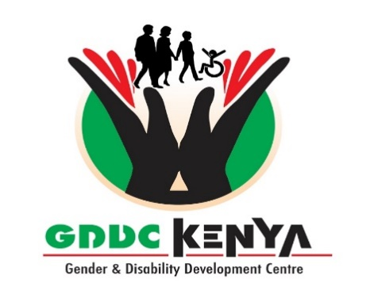

**Media Partner**

**The National Gender and Disability Mainstreaming. Inclusion Excellence Awards 2024**

**Overview**

The Gender and Disability Centre will hold its National Gender and Disability Mainstreaming Excellency awards to celebrate excellence in Diversity in, Leadership and Governance, excellence in service and excellence in creating environment friendly and inclusively favorable and cohesive working conditions for men, women and person with disabilities. This will be the 9th awards ceremony. Through; Government monitoring institutions, Private NGOs, Public Via our GDDC website [www.gddckenya.org](http://www.gddckenya.org) we are sampling, short listing and awarding various organizations as will be seen during the awards dinner at Laico Regency on 20th Dec 2024. All the 30 winners are kept as a secret from the public and the press until the dinner night. We have invited His Excellency, the President of the Republic of Kenya, Dr William Ruto PhD to Launch the DiverseKenya awards.

The Diversity in Governance Awards will honour Government Ministries,Counties Departments and Agencies, non-profits and Private Institutions who are ahead of the curve in embracing diversity at the highest levels of their organizations, exemplifying good practices in building and benefiting from racially and ethnically diverse boards of governance.

Successful strategies of recipients (especially private institutions and NGOs) include the establishment and implementation of diversity policies; outreach to diverse communities; and measurement and reporting on diversity mainstreaming goals.

GDDC will bring together over **500 Organizations** from all cadres of Government Public and Private Institutions. 30 organizations will walk away with awards of different categories.

**Media Partner.**

The media house will champion the publicity of the awards and ensure that relevant government and private institutions Participate in the launching of the DiversityKenya supplementary, these institutions will be given chances to pride of their initiatives and achievements related to mainstreaming both gender and disability in their works. Recognition of their respective employees Persons with Disabilities can be mentioned. Show the mainstreaming of both Gender and Disability nationally to change lives of Kenyans of either gender and Persons with Disabilities in the respective fields. Ideally the Corporate or Individual MUST have supported the implementation of viable Gender and disability mainstreaming performance indicators such as; having a working gender policy, GBV Prevention policy and has within his/her tenure improved on the workplace accessibility of Person with disabilities with enabled working amenities for PWD.

Richard S. Nasong`o, Chief Awards Convener 2024

**Gender and Disability Development Centre**